**MESD Documentation LMS-38-Files-repository**

**Purpose**

To allow having a file system on the server that the CMS site exists in, that is accessible to the Administrator for use

**Background**

There may be times that and administrator needs to store files out of the site so that we can have redundancies that don’t depend on the site, like backup files and configuration tools and info that can be used on the site. This feature aims to address this.

**Set up**

The file system repository allows access to files which have been uploaded (e.g. via FTP) into designated folders on the server. (Note that these folders are not created inside the Moodle site, but on the server where Moodle is hosted.)

A file system repository may be available site wide for everyone or within an individual course (set up by admin) or for an individual administrator. But only the administrator can create and add repositories to profiles or courses. When a file from the file system repository is re-used elsewhere on Moodle, the teacher has the option to make a copy (a new, unconnected version) or to create a shortcut or alias. Once a repository has been created and files uploaded to it, the files can be made available within the file picker for use within a course.

1. The default file directory of the repository is /var/moodledata/repository.
2. Go to Administration > Site administration > Plugins > Repositories > Manage Repositories;  
   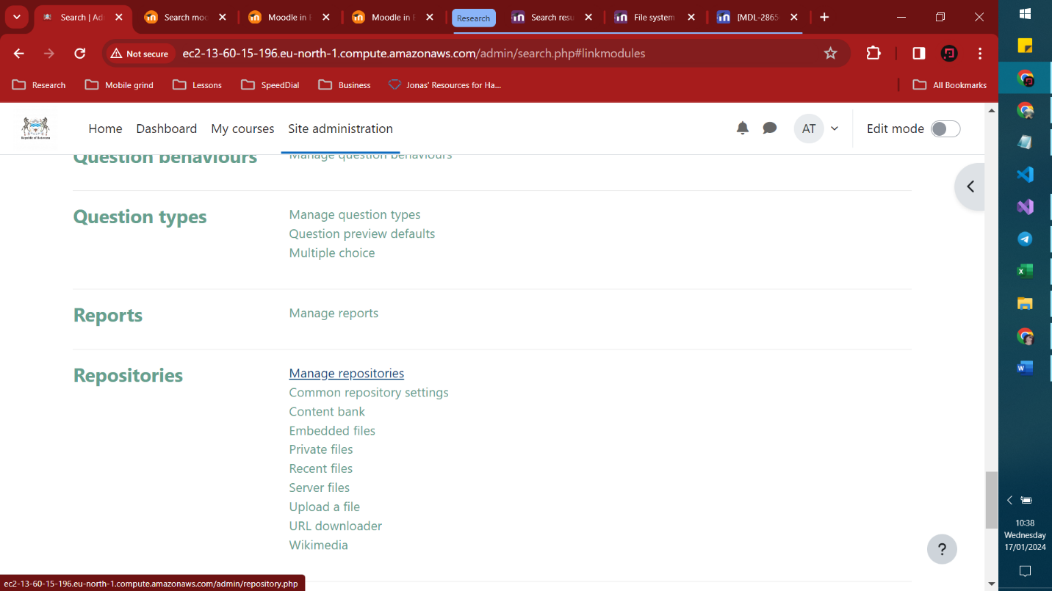
3. Select from the drop down next to File system "Enabled and visible"  
   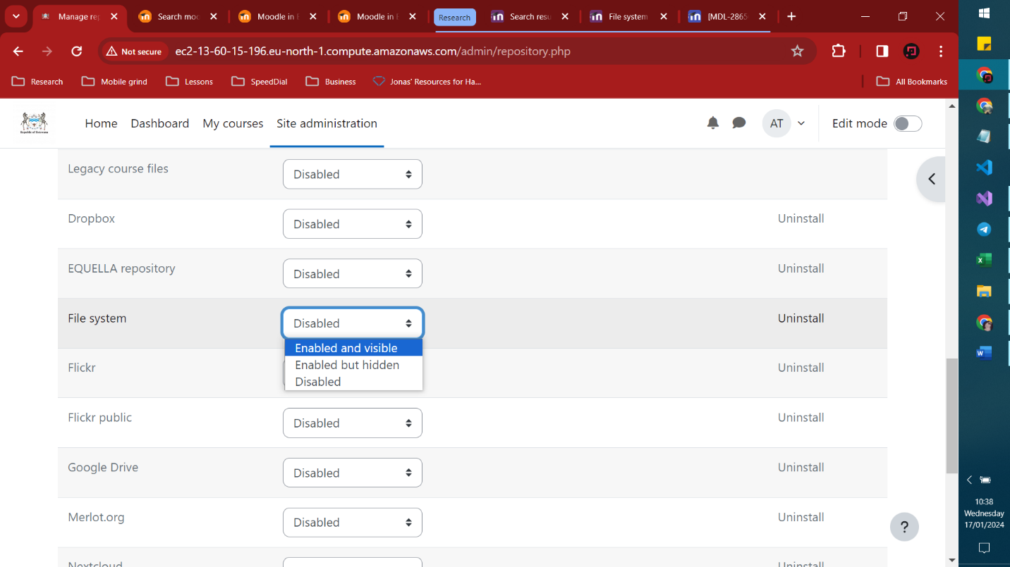
4. Click the settings link after you chose whether the file repository will work for courses and for personal use.

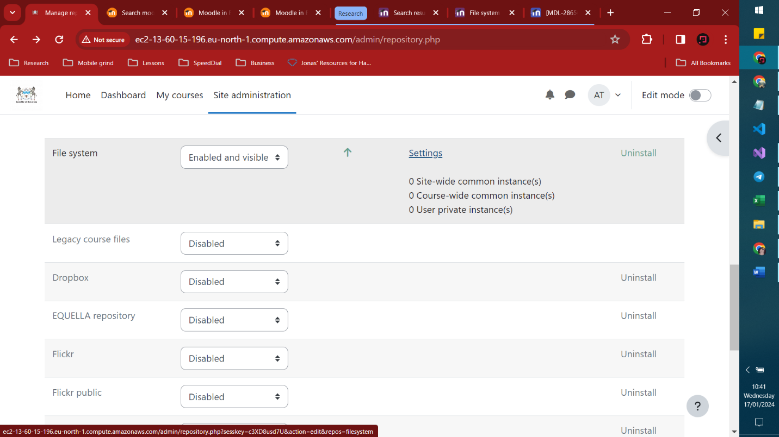

* Scroll down to Repositories instances of the site
* Click *Create a repository instance*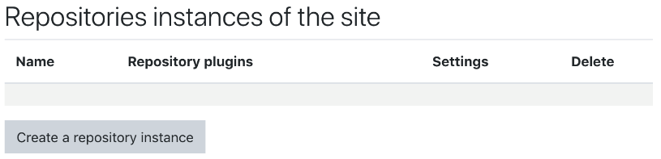
* Give it a name and (if there are several folders on the server) choose from the dropdown the one you want. Click **Save.**
* It will now be available in the file picker in all courses.

1. Make sure that you Check the top box allowing users to add a repository instance to the course.  
   - Go to the desired course and click on “repositories” in the administration block  
   - Scroll down and click "Create File System instance"

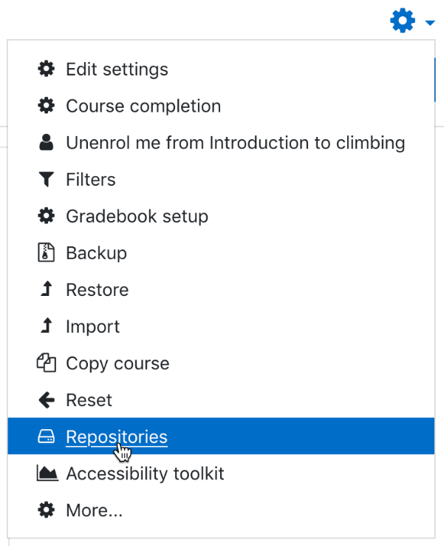

There is just one capability needed to view this feature in full. (repository/filesystem:view)